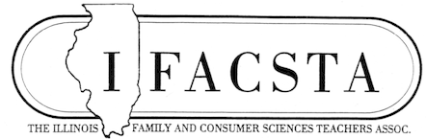
Newsletter May 2021
Congratulations on completing ThIS unique year! 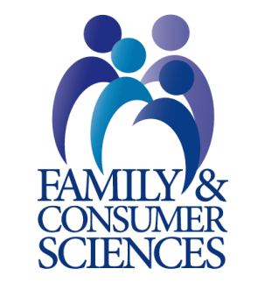
SUMMER CONFERENCE
We are looking forward to a summer of great Professional Development at our Annual Summer Conference at the I-Hotel, July 19-20, 2021. There will be something for everyone.
Please register ASAP to get the best rates. You may register by logging on to the IFACSTA website, the IACTE website, or by printing the form and mailing it. Until June 18, there is a special room rate at the I-Hotel of $109.00 which includes a continental breakfast.
There will be ample room for social distancing, and the hotel will require us to follow state guidelines at the time. (Vaccinated individuals will not be expected to social distance according to University guidelines.)
??? We are in search of a hostess for each session. Please let Dr. Kay Smith facs.oths@gmail.com know if you are interested, and if there is a particular session you are interested in hosting. Note that there may be minor changes as time draws near.
Most of the conference sessions and events are listed below.

Monday, July 19 Katharine Bensinger LCPC, and Kevin MClure LCPC, PEL ParenTeach, LLC, kevin@parenteach.com
Statewide Pilot Supports CTE FACS Educators with Multi- Discipline Unit of Curriculum

Katie Sudler, FONA International, Geneva IL 60134, KSudler@fona.com
The Science Behind Food and Flavor
Katelin Arseneau, Reed-Custer High School, katelin.arseneau@rc255.net
Let’s Take a T.R.I.P.P.! (Teaching Design with- Technology, Reflection, Independent, Partner, and Project)
Nancy Bitner, ROE 30, IFACSTA member, (President-elect), nancybitner@yahoo.com
How to Use Perkins and CTE Funds That Will Grow Your Programs
Deanna Williams, champaignmanager@yahoo.com
Quilting in the Valley
Jill Craft, University of Illinois Department of Food Science and Human Nutrition, jnorth@illinois.edu
What’s Happening in Food, Nutrition, and Hospitality at the University of Illinois (opportunities for students – careers)
Patti Kozlowski, IFACSTA Past-President
Finances in Retirement
Regina Birch, IFACSTA Treasurer, FCS teacher/FCCLA sponsor, Alton
rbirch@altonschools.org
Making Lemonade out of Rough Times
Luncheon with Speaker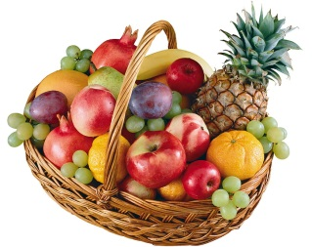
Marile Quintana, Paige Vande Vusse, University of Illinois, Urbana Champaign, marile@illinois.edu
Expanding the Impact of Secondary Teacher Relationships on Student Success

Tours
Lodgic Everyday Community, 1807 S. Neil, Champaign, IL 61820, Teresa Brown, teresa.brown@lodgic.org
Bohemia Boutique, A Small Woman Owned Business, Urbana, IL, Milea Hayes, bohemiaonmain@gmail.com
(3rd tour in process)
Evening session: Deb Holmes, Creating Something for Your Classroom

Tuesday, July 20 Monica Nyman, St. Louis District Dairy Council, mnyman@stldairycouncil.org
Dairy 101: Resources Outside of the Cooking Lab
Amanda Ann Ramsden, Wilco Area Career Center, aramsden@wilco.k12.il.us
Second Chances (Upcycling with Student’s Projects)
Amanda Perez-Rosser, Urbana High School, arosser@usd116.org
Technology Tool Exploration
Dr. William Gingold, Department of Family Medicine, UIUC (retired), and Mature Markets, Inc., Founder/President, williamgingold@gmail.com
Students Ascending the Expectancy Effect (Performance in pre-school education – Child Development)
Regina Birch
Building the C in FCCLA
Leyi Wang DVM, University of Illinois College of Veterinary Medicine, leyiwang@illinois.edu
How Does a Pandemic Affect Our Food Supply?
Le Ann Meyer, Draperies and Interiors, Savoy IL, Drapes90@hotmail.com
Custom Window Designs
Pam Weber, ICTA, pweber221@aol.com
Springfield Happenings – What’s Next?
Deb Holmes, IFACSTA member, Past-Pres., holmes3037@mchsi.com
Scraps, Scraps Everywhere (Ideas for use of scraps in sewing class)
Plated Luncheon, featured speaker, business meeting, awards, installation of officers, raffle/silent auction
Phil Edwards, American Water, dgfireproof22@yahoo.com
Road Blocks to Building Blocks
*********************

New & Nearly New CTE Teacher Workshop
This workshop is designed for the new and nearly new CTE teacher that did not go through a four year university teacher education program. However, the sessions will be applicable to all new and nearly new CTE teachers. Topics that will be covered are: Lesson Plan Development, Teaching Methods, Classroom Management, Special Populations, Inclusion, Diversity, Virtual Teaching, Lab Management, Professional and Student Organizations, Resources, Professionalism and Fun Activities for the classroom.
Funds may be available for those who do not have a school district, Area Career Center or EFE System to pay the registration fee. Please contact info@iacte.org.
A block of rooms is reserved at the Par-a-Dice Hotel at a rate of $94 plus tax. Use the code 0726NTW when reserving your room. To make a reservation, call 800-547-0711 or use www.paradicecasino.com/groups . This room rate will be guaranteed through July 8, 2021.
Refunds requested in writing will be accepted through July 23, 2019. Limited registrations will be accepted after July 25, 2019.
**********************
***Our deepest sympathies for our President, Anne Emery, in the passing of her father
***ACTE Region III Conference, Prior Lake MN, June 16-18, 2021, in person
***Save the Date: 92nd Annual IACTE Conference – CTE - Essential for the Future Workforce! Bloomington Normal Marriott Hotel and Conference Center, February 17-18, 2022
**********************
“Educating the mind without educating the heart is no education at all.” Aristotle
See you at the conference!!!

