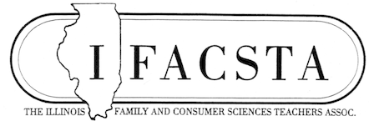
Newsletter August 2021
Best wishes for a fantastic 2021-22 school year.
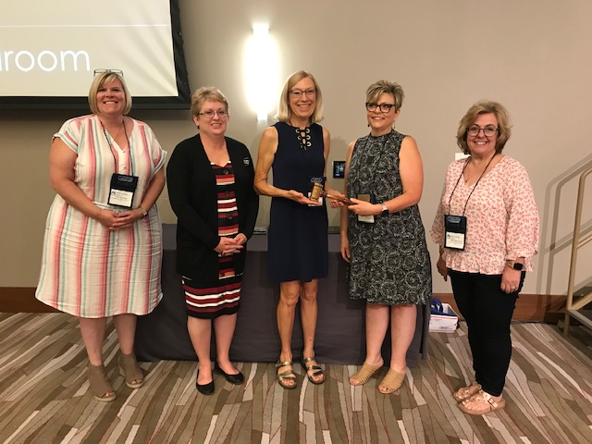
New IFACSTA Officers Installed at Annual Conference
Pictured are new officers, Kelly Tripplett, Secretary, Lincoln Community High School; Regina Birch, Treasurer, Alton High School; Dr. Kay Berberich Smith, President, O’Fallon Township High School (retired); Anne Emery, Past-President, Crab Orchard High School; and Nancy Bitner, President-Elect, Regional Office of Education #30.
Annual Conference Offered Eleven Credit Hours of Professional Development
Thank you so much for your involvement in our annual conference July 18-20 in Champaign themed ‘Strengthening Families – Preparing for Careers”. With your participation and input from members, we had another successful conference for our members. It was so wonderful to get together, reconnect with old friendships and make new ones, especially since we didn’t get to have our conference in person last year.
Eighteen sessions, two luncheon speakers, three tours, and an evening lesson provided eleven professional credit hours that included topics on technology, teaching methods and tips, culinary, nutrition, child development, interior design, fashion and textiles, psychological and emotional issues, pending state laws, and funding. New officers were elected and installed at the annual business meeting.
Congratulations award winners! You make our organization shine!
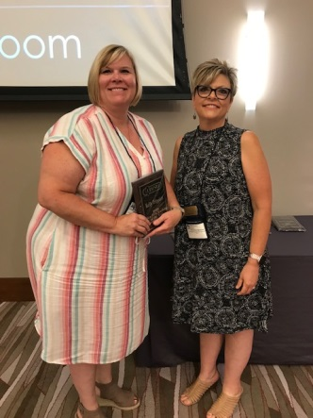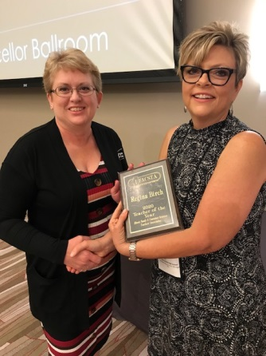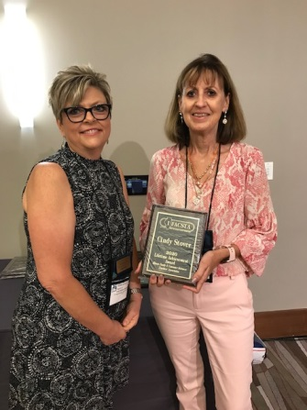
President Anne Emery presents awards: 2020 FCS New Teacher of the Year, Kelly Tripplett; 2020 Teacher of the Year, Regina Birch; 2020 Lifetime Achievement Award, Cindy Stover.
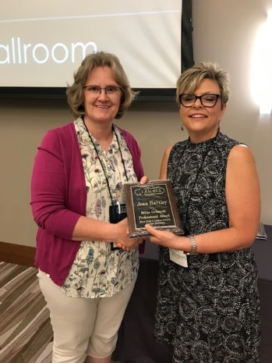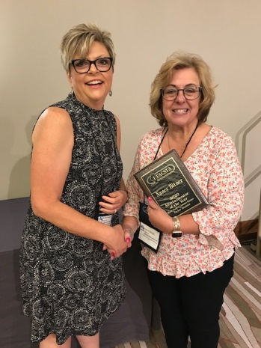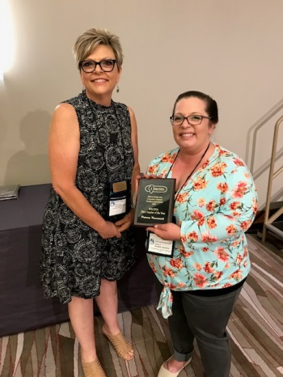
President, Anne Emery presents awards: Billye Griswold Professional Award, Joan Hartley; 2020 Administrator of the Year, Nancy Bitner; 2021 New Teacher of the Year, Patricia Krummrich.
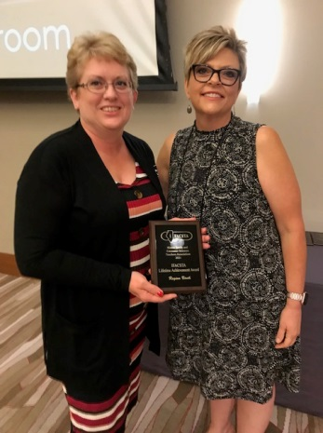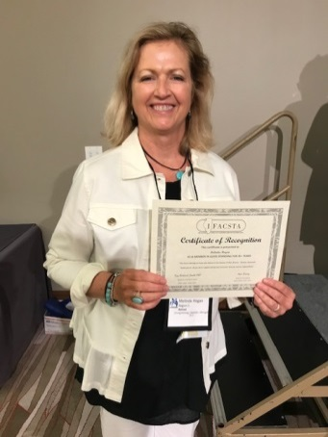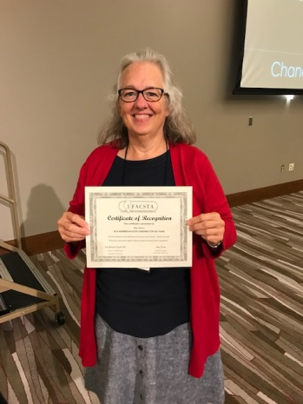
2021 Lifetime Achievement Award, Regina Birch;
35 + Years Membership. Melinda Hogan; 30 + Years Membership, Pam Furrer
(Not Pictured): Martha Zimmerman, 60 Years; Marjorie Houghland, 55 Years; Patti Kozlowski, 45 Years.
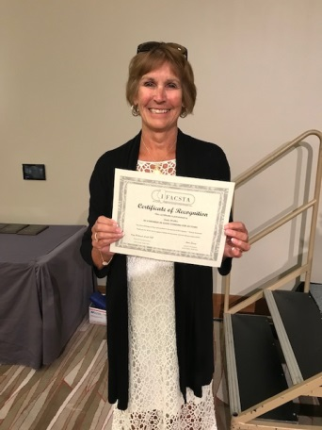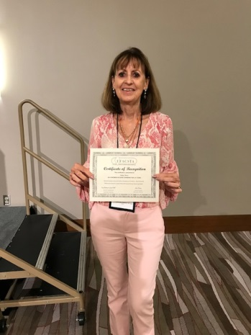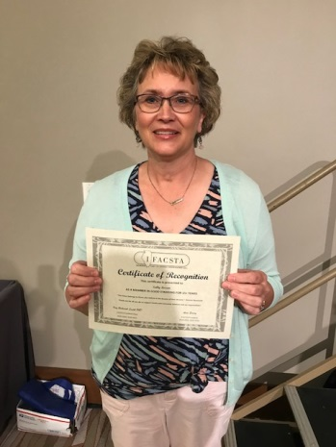
20 Years, Linda Walker; 15 + Years, Cindy Stover and Sally Lessen. Not pictured, 10 Years, Brittney Bauer.
Award winners not pictured include:
2021 IFACSTA Teacher of the Year: Chef Matt Barker, Instructor at the Technology Center of DuPage
2021 IFACSTA Postsecondary Teacher of the Year: Amy Ponce, Instructor at Illinois State University
2021 IFACSTA Administrator of the Year: Lynne Benson, Administrator at Vernon Hills High School

.
Sessions, Featured Speakers and Tours
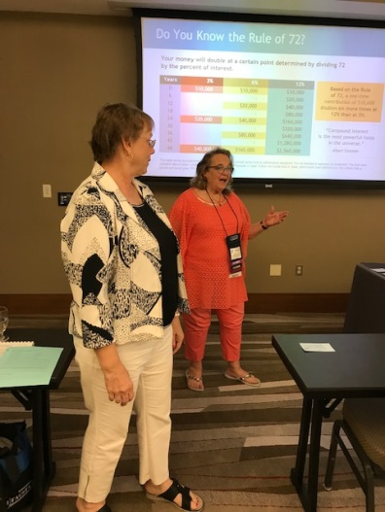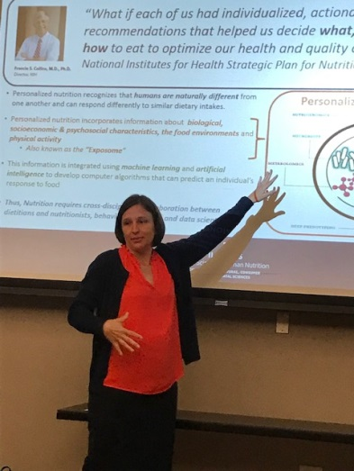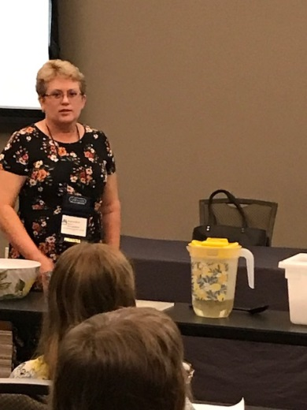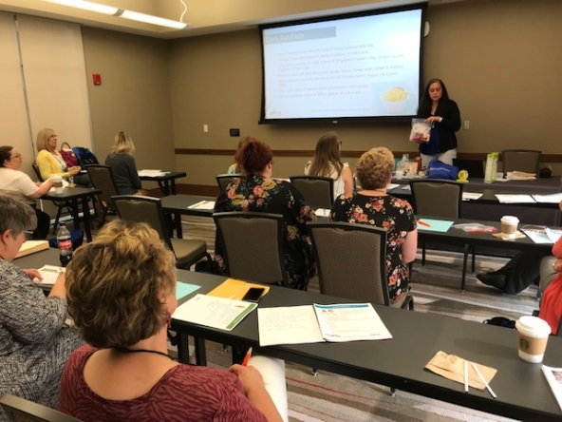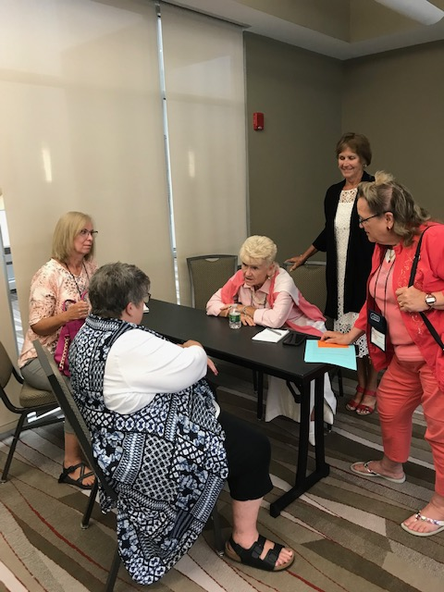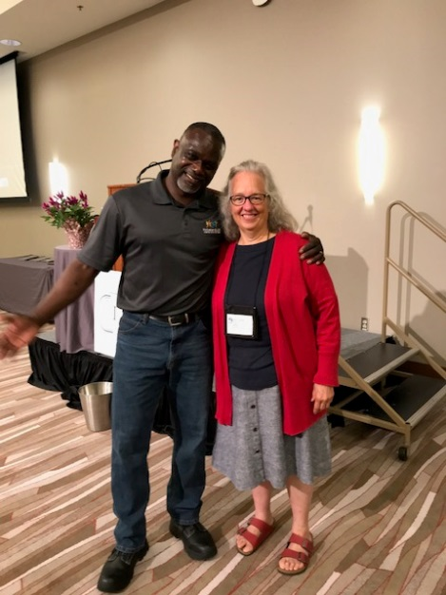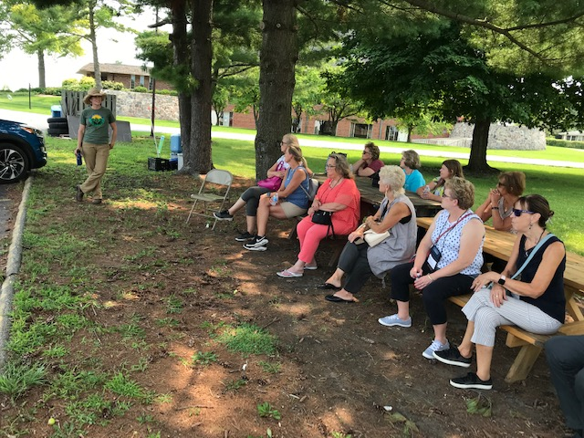
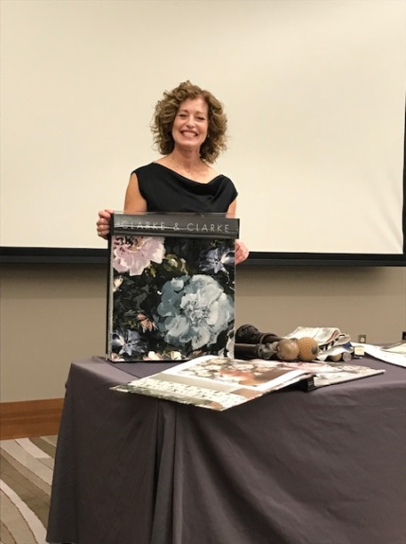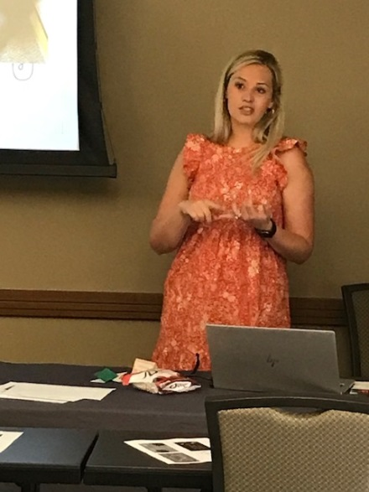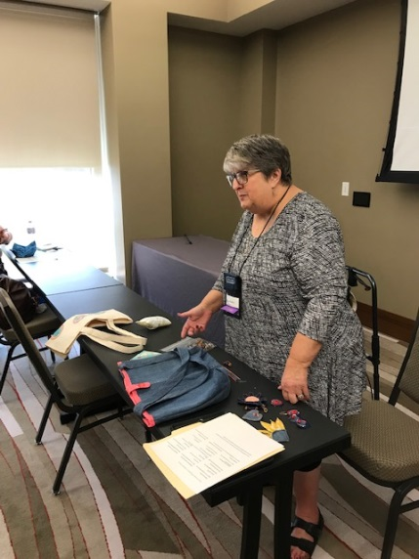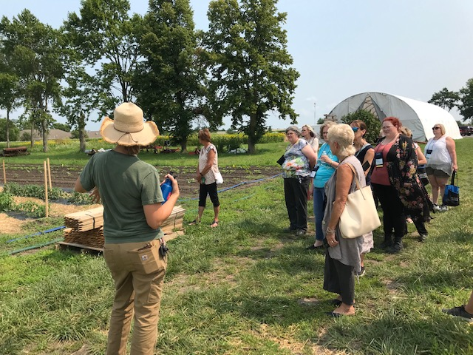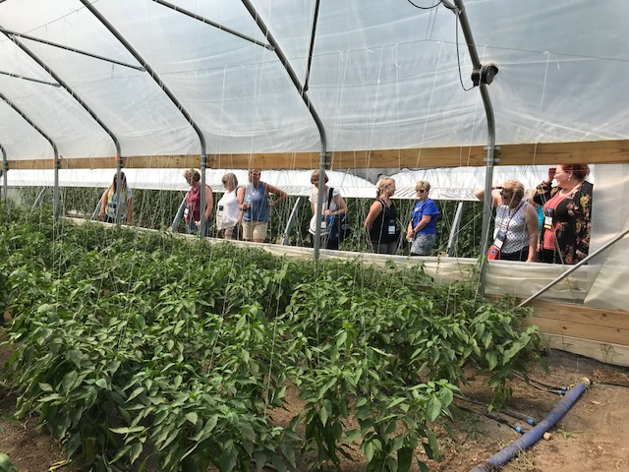
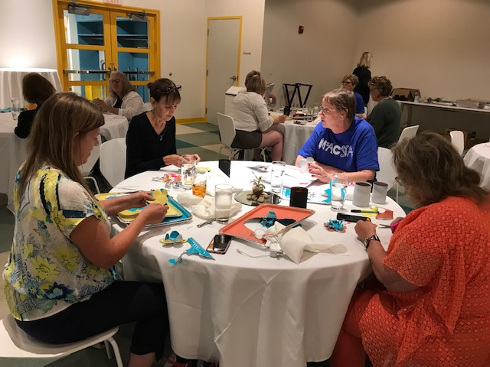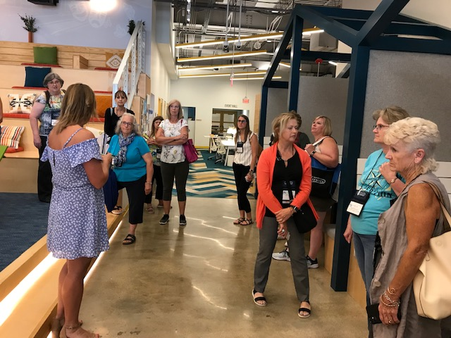
***If you have not yet submitted a news article about your conference attendance, please do so, as this is one way to promote FCS for your school, and IFACSTA. An article template is located at the end of this newsletter.
***Check out ACTE webinars on Recruiting and Marketing CTE in a Virtual World; Driving Ownership in the Classroom Through Entrepreneurship, Teamwork, and Cross-Curricular Collaboration, and more.

Hopefully, the new school year is going well. Please take advantage of the many opportunities for professional development.

ACTE CareerTech Vision Early Bird Rates Extended to Aug. 31
The most important event for career and technical educators, ACTE’s CareerTech VISION will provide unparalleled networking, inspiring keynote speakers, hundreds of concurrent program sessions covering multiple CTE sectors, timely equity and access topics, innovations in CTE, an in-person Expo, and more. This year’s event happens in New Orleans, Louisiana, December 1–4. In-person rates include access to both in-person and virtual programming. Please note, the early bird rates have been extended to Aug. 31, so there’s still time to secure the most affordable way to attend VISION! Not able to attend in-person? Join us virtually for a dynamic and specially curated content. Learn more and register here: https://www.careertechvision.com/index.cfm

Upcoming Webinars
Mark your calendar for these upcoming free webinars, covering innovative best practices and inclusion, access, equity and diversity in CTE.

- Designing a College and Career Pathways System, sponsored by NC3T, on Aug. 27 at 11:00 a.m. ET
- Teaching Innovative CTE: Bringing Industry into Your Classroom with Real-world Projects & Skills on Sept. 1 at noon ET
- Making CTE Classrooms More Inclusive for LGBTQ+ Students on Sept. 8 at 3:00 p.m. ET
- Part 2: Confronting Isms in the Classroom on Oct. 5 at 2:00 p.m. ET

Learn more and register here: https://www.acteonline.org/webinars/

ITEC Conference
October 22 - 23, 2021
Normal, IL
http://www.teaillinois.org/register2

IBEA Fall Conference Conference
November 4 - 5, 2021
Virtual
https://www.ibea.org/fall-conference

Sincerely,

Cindy Stover
IACTE

Coming Up….
ACTE CareerTech Vision Conference: New Orleans LA, November 30-December 4, 2021, Virtual or in-person options; Early Bird rates extended through Aug. 31. Opening session: “The Secret History of Home Economics”
92nd Annual IACTE Conference: Bloomington, February17-18, 2022
The Call for Presentations is now open for the 92nd Annual IACTE Conference - CTE - Essential for the Future Workforce. The conference will be held February 17 - 18, 2022, at the Bloomington/Normal Marriott Hotel and Conference Center. At this time, we are planning for an in person conference. Each affiliate is responsible for 5 - 7 sessions that will be of interest to your affiliate members.
The Call for Presentations is on the IACTE website and can be found here: IACTE Call for Presentations. The deadline to submit a proposal is October 5,2021

IFACSTA Board 2021-2022

President – Kay Smith, Ph.D.
President Elect – Nancy Bitner
Past President – Anne Emery
Treasurer - Regina Birch
Secretary - Kelly Tripplett
Membership Chair - Barb Manley
Public Information / Legislation Chair - Patti Kozlowski
Webmaster - Lauren Schumacher
E-Communications - VACANT
Middle School Teacher Representative - VACANT
Post-Secondary Educator Representative - Sally Arnett-Hartwick, Ph.D.
Retired Teacher Representative - Melinda Hogan
ISBE Representative - Kristina Valentine
FCCLA Representative - Marta Lockwood
IACTE Executive Director - Cindy Stover
Region 1 Representative - Brittney Bauer
Region 2 Representative - Deb Holmes
Region 3 Representative - Sally Lessen
Region 4 Representative – VACANT
Region 5 Representative - Jessie Day
Region 6 Representative – VACANT

If you would like to serve as the next President Elect, or know someone who would, please email Dr. Kay Smith at facs.oths@gmail.com . The term would be July 2022-July 2023.
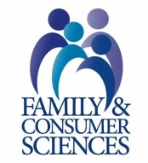
***Thank you so much to Dr. Sally Arnett-Hartwick and Sally Lessen for finishing out the vacated Past-President’s term for 2019-2021.
***Thank you to all the officers who offered to step up and take the extra year in their term due to the conference not being in person and the Covid situation in 2020.
***Thank you to members who provided input/suggestions for our next conference. We had lots of great ideas and comments. Know that your help on the conference committee is always welcome.
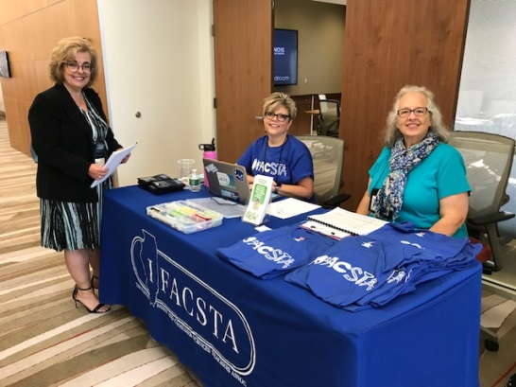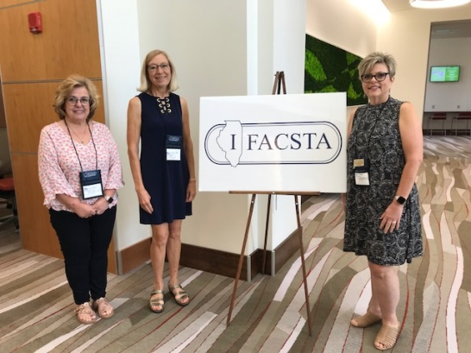

ACTE’s August Advocacy Week 4: Attend or Host an Event with Your Policymaker
During the August recess, Members of Congress often host events and meetings to connect with their constituents. ACTE has created a toolkit for getting the most out of virtual and in-person events with your federal policymakers. READ MORE

ACTE Seeking IAED Mentors & Mentees ACTE’s mentorship program, offering professional development opportunities to help cultivate more diverse and inclusive work environments for career and technical educators, seeks to support association members interested in inclusion, access, equity and diversity (IAED) — those who are interested in becoming a mentor in ACTE’s IAED Mentorship Program should apply by Aug. 31, or a mentee by Sept. 30. The IAED Mentorship Program is generously sponsored by IMAGO. _____________________________________________
Mock Macaroni (from 1824) Break some crackers in small pieces, soak them in milk until they are soft; then use them as a substitute for macaroni. (From Secrets of the Great Old-Timey Cooks –Historic Recipes, Lore & Wisdom by Barbara Swell.
PRESS RELEASE
Help Promote IFACSTA and your own professional development. Print your name, title and school on this news releases and send it to your local newspapers, radio stations, Facebook pages, school websites, etc.

FCS Teachers Meet at State Conference
The Illinois Family and Consumer Sciences Teachers Association (IFACSTA) held their annual State Conference, July 19-20, 2021 in Champaign IL at the I-Hotel and Convention Center. About 30 teachers from across the state of Illinois were in attendance. Among them was _____________________________________ from_____________________________.
The theme of this year’s conference was “Strengthening Families – Preparing for Careers”.
Of special interest was the focus of what is new and upcoming in Family and Consumer Sciences. Sessions included technology use in FCS, Culinary, FCCLA, fashion, child development, relationships, nutrition, home and business trends in décor, teaching methods, current pending legislation on education, and much more. Participants were able to choose sessions that best fit their needs as a Family and Consumer Sciences educator.
The conference was a vital experience for the professionals attending, helping them to improve curriculum and instruction in classrooms all over the state. It was also an opportunity to network with other FCS educators and to help them understand today’s students better.
Family and Consumer Science Educators are educating students for careers in the fields of culinary, nutrition, early childhood education, teaching, gerontology, interior design, retail, fashion design, textile design and many more. Thank an FCS teacher today! Contact your local FCS educator and ask how you can help them give their students opportunities to learn within their community.
Check out our website and Facebook page to see what we are doing. www.ifacsta.org

