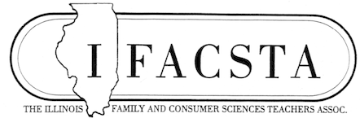
Newsletter, May 2022

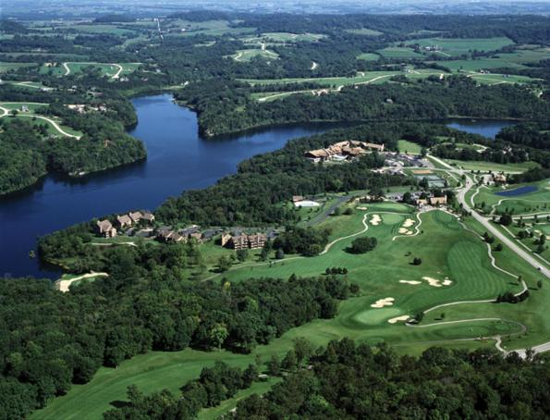
IFACSTA Annual Conference
“FACS, Winning the Game of Life”
Eagle Ridge Resort & Spa, Galena IL
When: July 18-19, 2022
Fee: $250 Member (login first)
$190 Student or Retired
$315 Non-member
$50 late fee after July 1

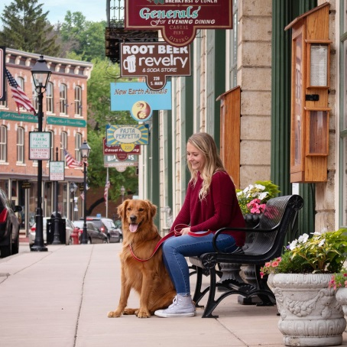
Presentations for PD include topics on cake decorating, growing herbs and using them in the classroom, sewing curriculum, purchasing sewing machines for your classroom, using essential oils, building a stronger FACS program, strength based parenting/teaching, FCCLA, Zentangles, utilizing iCEV, success through positive parenting education, ECE credentials, roundtable, fashion forecasting, and much more.
Book exchange: Bring books and other teaching materials to share and exchange.
Tours will highlight the history of Galena, DeSoto House Hotel, Galena Garlic Co. and Embe Eatery.

Make plans now! See you in Galena
2022 IFACSTA Conference continued
Come and visit with vendors, network with others in the FACS field, and obtain professional development credit hours.
Hotel Reservations Deadline June 24, 2022:
Eagle Ridge Resort & Spa, 384 Territory Drive, Galena, Il 61036
CALL FOR RESERVATIONS 1-800-892-2269, GROUP # 6977FA. The rate is $159+tax
Hotel Reservations Deadline June 24, 2022
The hotel requires payment for the first night. Cancellation up until seven days prior to the stay will result in a $35 cancellation fee. Cancellation within seven days, the first night’s payment will be forfeited.
Refunds
Refunds must be submitted in writing by July 1, 2022 and will be subject to a $50 processing fee.
There are no refunds after July 1, 2022
President’s Corner
*Looking forward to our annual conference in Galena. Make plans to come learn, and connect with fellow professionals in our field.
*If you would like to join our executive board, please let me know facs.oths@gmail.com. We would love to have you. Fresh ideas are always welcome.
*Look for those who excel in our field, and send in your award nominations to Past-President, Anne Emery anne.emery@cocusd.org and see the form Link to Nomination Form
*Let me know your activities or noteworthy events or projects so we can put them in our newsletter, webpage and on our Facebook page.
*If you would like to be a hostess for any of the sessions at the conference, please contact Deb Holmes at holmes3037@mchsi.com Several are needed.
*Thank you to all those working hard on the conference committee: Deb Holmes, Brittany Bauer, Regina Birch, Sally Lesson, Melinda Hogan, Cindy Stover, Anne Emery, Joan Hartley and Kay Smith.
Dr. Kay Smith
IFACSTA Awards will be presented at the Annual Business Meeting July 19 in Galena: Please submit your nominations as soon as possible to Past President, Anne Emery anne.emery@cocusd3.org . The awards form link is Link to Nomination Form. And the deadline is May 31.
IFACSTA Awards Descriptions
- Carl Perkins Community Service Award - This award recognizes individuals who have used CTE to make a significant impact on their community and demonstrated leadership in programs and activities that promote student involvement in community service.

- Teacher of the Year - This award recognizes the finest career and technical teachers at the middle/secondary school level who have demonstrated innovation in the classroom, commitment to their students and dedication to the improvement of CTE in their institutions and communities.

- Administrator of the Year - This award recognizes administrative CTE professionals at the school, district, county, state or federal level who have demonstrated leadership in ensuring teacher and student success and have made significant contributions toward innovative, unique and effective career and technical education programs.

- New Teacher of the Year - This award recognizes new CTE teachers who have made significant contributions toward innovative and unique career and technical education programs and shown a professional commitment early in their careers.

- Lifetime Achievement Award
This award recognizes CTE professionals for their leadership on behalf of ACTE, their innovations in CTE and their contributions to the field over an extended period of time.

- Post-Secondary Teacher of the Year - This award recognizes the finest career and technical teachers at the postsecondary level who have demonstrated innovation in the classroom, commitment to their students and dedication to the improvement of CTE in their institutions and communities.

- Career Guidance Award - This award recognizes school counselors and career development professionals who have demonstrated commitment to connecting students with opportunities for success, shown innovation in career exploration and development, and have advocated for CTE as a viable option for all students.

- Teacher Educator of the Year - This award recognizes teacher educators who have demonstrated innovation in teacher education, leadership in improving CTE, and commitment to preparing teachers to deliver high quality CTE programs.

- Billye Griswold Award - A Billye Griswold Professional Award honors Billye Griswold for her professionalism throughout her teaching career. It is meant to honor a classroom teacher who has made significant contributions in the classroom in Family and Consumer Sciences, is considered to be an outstanding leader in the field and has an active FCCLA program.

Legislative Awareness

House Appropriations Committee Holds Hearing on Department of Labor FY23 Budget Request
On May 17, the House Committee on Appropriations' Subcommittee on Labor, Health and Human Services, Education, and Related Agencies held a hearing with Secretary of Labor Marty Walsh to discuss the FY 2023 budget request for the Department of Labor. READ MORE

Employment and Training Administration Hosts Advisory Committee on Apprenticeship Meeting
On May 17, the Department of Labor’s Employment and Training Administration hosted a meeting featuring stakeholders focused on how to expand access to apprenticeships. READ MORE

House Holds Hearing on Aviation and Aerospace Workforce
On May 12, the House Committee on Small Business' Subcommittee on Innovation, Entrepreneurship, and Workforce Development held a hearing on the innovation and workforce needs of the aviation and aerospace industries. READ MORE

Department of Education Announces Presidential CTE Scholars
On May 12, Secretary of Education Miguel Cardona announced the 58th class of U.S. Presidential Scholars, which recognizes 161 high school seniors for their accomplishments in academics, arts and CTE. 20 outstanding CTE scholars were recognized this year. READ MORE

DC Digest: May 9–15
Last week in Washington, both chambers of Congress were in session and several CTE-related items saw legislative action, including the America COMPETES Act/USICA, where the conference committee met for the first time, and a bill to support CTE program graduates in small businesses. READ MORE

Department of Education Holds Summit on Mental Health in Higher Education
On May 23, the Department of Education held a virtual summit on mental health in higher education with a particular focus on supporting students with disabilities as they transition from school to careers. READ MORE

House Passes WIOA Reauthorization
On May 18, the House of Representatives passed a reauthorization of the Workforce Innovation and Opportunity Act (WIOA) by a vote of 220–196. READ MORE

House Science Committee Holds Hearing on Electric Vehicle Workforce
On May 20, the House Committee on Science, Space and Technology held a field hearing in Michigan on the development of the electric vehicle workforce. READ MORE

School Year 2022-23 Team Nutrition School Meals Recipe Development Grant
(Letter from Timothy Murphy, ISBE)
Good afternoon!
I work in the Illinois State Board of Education Nutrition Department. We work primarily with school nutrition professionals with federal child nutrition programs such as the National School Lunch Program. I came across the Illinois Family and Consumer Sciences Teachers Association online and wanted to share this ISBE grant opportunity with you. The grant could be a great collaborative project with school nutrition professionals and educators in high schools across the state. Please help us spread the word! Let us know if you have any questions. Thanks!!! – Tim Murphy, ISBE Nutrition Department

Apply for the Team Nutrition School Meals Recipe Development Grant
ATTENTION ADMINISTRATORS, SCHOOL NUTRITION PROFESSIONALS, AND EDUCATORS: Do you have a group of high school students interested in culinary arts? Are you looking for a fun project for your class or student group? The Illinois State Board of Education Nutrition Department is excited to announce a grant opportunity that will see high school students developing National School Lunch Program recipes that celebrate Illinois agriculture.
ISBE is seeking Request for Proposals (RFP) for the opportunity. Registration is under way for a webinar on the School Year 2022-23 Team Nutrition School Meals Recipe Development Grant.
WHAT: Team Nutrition School Meals Recipe Development Grant Opportunity Webinar
WHEN: 2-3 p.m. Wednesday, April 27
REGISTRATION: https://register.gotowebinar.com/register/4945858810774533648
Successful grant candidates will collaborate to guide students with recipe development and plan related activities such as field trips and local taste tests. As a culmination to the project activities, ISBE will host a recipe tasting event for all grant recipients to celebrate the students’ efforts and bring participants together to sample recipes created by themselves and their peers. Recipes will focus on locally produced vegetables such as pumpkin, corn, lima beans, green peas, asparagus, green beans, and winter squash. ISBE will encourage school food authorities to incorporate the unique food practices found in their geographic area when developing recipes.
Applicants must be a School Food Authority (SFA) in Illinois with a high school (grades ranging from 9-12) for which the high school:
- participated in the National School Lunch Program (NSLP) during School Year 2019-20; and
- participated in the National School Lunch Program (NSLP) or the Seamless Summer Option (SSO) lunch for School Year 2021-22 and will continue to operate such a program during School Year 2022-23.
Please review the RFP and view the webinar for more detailed information. After the live webinar, a recording will be posted at https://www.isbe.net/Pages/team-nutrition.aspx.
The deadline to apply for the grant RFP is 4 p.m. May 31, 2022. Each applicant may request up to $10,000. There will be a maximum of 20 recipients. For more information, visit ISBE’s Team Nutrition page.
Team Nutrition is an initiative of the U.S. Department of Agriculture to support the child nutrition programs through training and technical assistance for foodservice, nutrition education for children and their caregivers, and school and community support for healthy eating and physical activity. Recipients of the School Year 2022-23 Team Nutrition School Meals Recipe Development Grant are required to be or become a Team Nutrition school. Visit the USDA website for additional information on Team Nutrition schools: https://www.fns.usda.gov/team-nutrition.
Questions? Please email the ISBE Nutrition Department at cnp@isbe.net.
Nutrition Department, Illinois State Board of Education
100 N. First St., Springfield, IL 62777
Phone: (800) 545-7892 or (217) 782-2491
cnp@isbe.net, www.isbe.net/nutrition

Please visit www.isbe.net/nutrition for What’s New? announcements and resources from the ISBE Nutrition Department.

Tim Murphy
Principal Consultant
Nutrition Department
Illinois State Board of Education
tmurphy@isbe.net

See you at the IFACSTA Conference

